**DAILY ONLINE ACTIVITIES SUMMARY**

|  |  |  |  |  |  |  |  |  |
| --- | --- | --- | --- | --- | --- | --- | --- | --- |
| **Date:** | **18-06-2020** | | | | | **Name:** | **SRILATHA K KAMATH** | |
| **Sem & Sec** | **6 B** | | | | | **USN:** | **4AL17CS099** | |
| **Online Test Summary** | | | | | | | | |
| **Subject** | | **-** | | | | | | |
| **Max. Marks** | | **-** | | **Score** | | | **-** | |
| **Certification Course Summary** | | | | | | | | |
| **Course** | 1. **Pre-placement Training** 2. **Python Workshop On DA and ML** | | | | | | | |
| **Certificate Provider** | | | **-** | | **Duration** | | | **4hours** |
| **Coding Challenges** | | | | | | | | |
| **Problem Statement:** Python program to count number of lowercase characters in a string. | | | | | | | | |
| **Status: COMPLETED** | | | | | | | | |
| **Uploaded the report in Github** | | | | | **YES** | | | |
| **If yes Repository name** | | | | | https://github.com/alvas-education-foundation/Srilatha-K-Kamath-Daily-Report.git | | | |
| **Uploaded the report in slack** | | | | | **YES** | | | |

Online Test Details: -

Online Course Details:

Attended class on the topic Programming in C. [from 9.15am to 11am]

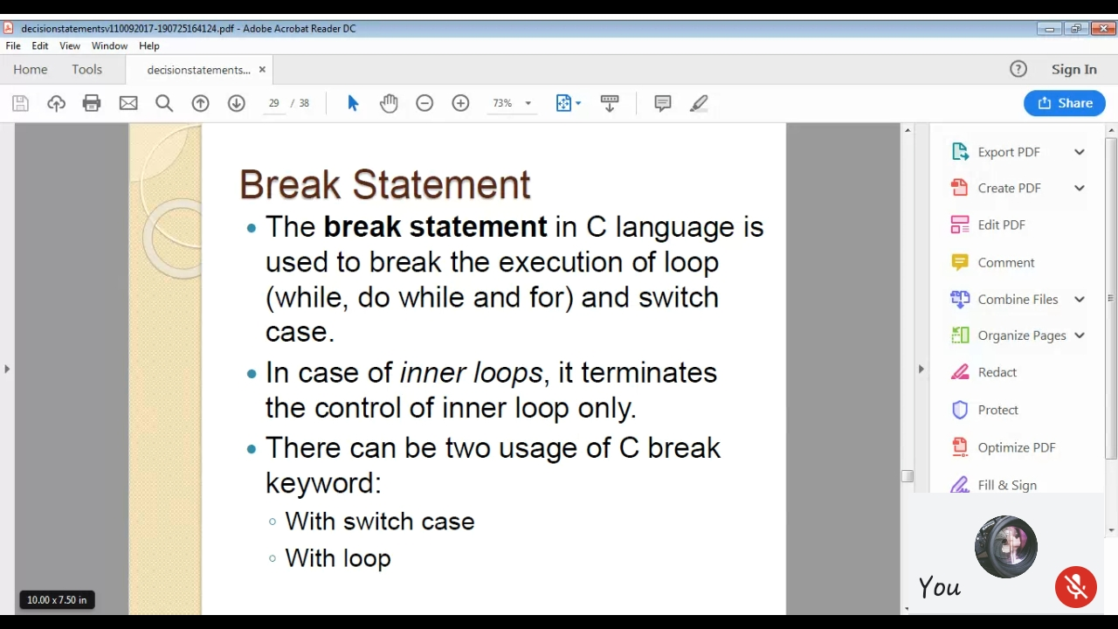

Attended Python Workshop on DA and ML. [from 11am to 01.40pm]

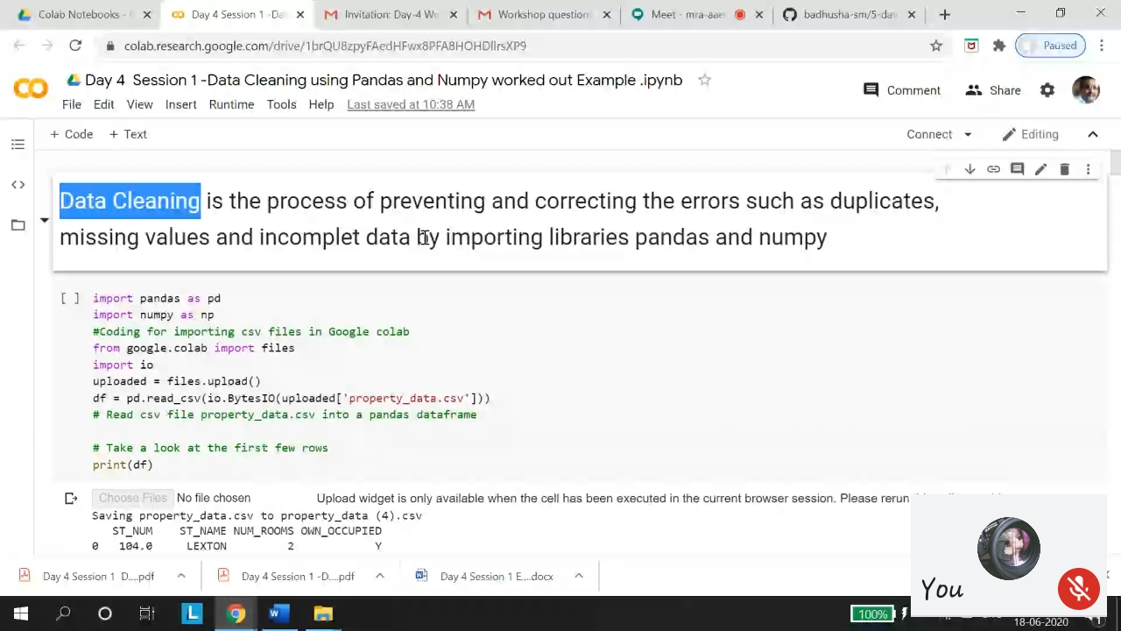

Online Coding Details: Python program to count number of lowercase characters in a string.

